AI MECH LAB
AI Course — Beginner Track
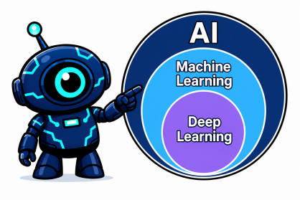
Module 1, Topic 1.1
What is AI, ML, and Deep Learning
Lesson
If you've spent any time around the word "AI" lately, you've probably heard it used to mean about five different things depending on who's talking. A marketer uses it to mean "smart software." A researcher uses it to mean something much narrower. Before you build anything, you need these terms pinned down precisely.
Artificial Intelligence (AI) is the broadest term. It refers to any system that performs tasks which would normally require human intelligence — recognizing a face, understanding a sentence, deciding where to move a robotic arm. AI is the goal category, not a specific technique. A simple chess-playing program from the 1990s that follows hand-coded rules is technically AI. So is a modern system that writes essays. They achieve "intelligent behavior" through completely different means.
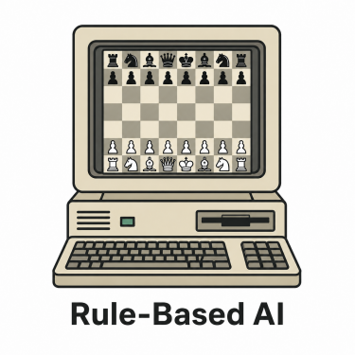An early rule-based chess program — AI, but no learning involved.
Machine Learning (ML) is a subset of AI — specifically, AI achieved by learning patterns from data rather than being explicitly programmed with rules. Instead of a human writing out "if the sensor reads above X, do Y," you give the system a large number of examples, and it works out the pattern itself. This shift is what made modern AI possible: rules written by humans don't scale to the complexity of real-world problems like image recognition or language, but patterns learned from thousands or millions of examples can.
Deep Learning (DL) is a subset of ML — specifically, ML done using a structure called a neural network, loosely inspired by how neurons connect in a brain. "Deep" refers to having many layers of these connected units stacked on top of each other. Deep learning is what powers most of the AI systems getting attention right now — image recognition, large language models, generative design tools.
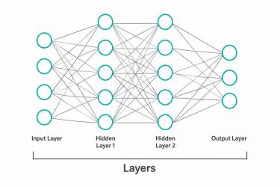A neural network: input layer, hidden layers, output layer.
So the relationship is a set of nested boxes: AI contains Machine Learning, which contains Deep Learning.
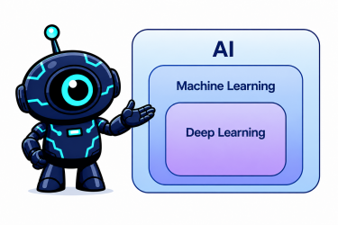The nested relationship between AI, Machine Learning, and Deep Learning.
Every deep learning system is machine learning. Every machine learning system is AI. But not every AI system uses machine learning, and not every machine learning system uses deep learning — plenty of ML techniques, like decision trees or simple regression, aren't neural networks at all, and are often the better choice for smaller or more structured problems.
Why this distinction matters practically, not just academically
If someone tells you "we're adding AI to this product," that sentence alone tells you almost nothing about how it works, how much data it needs, or how predictable its behavior will be. Those things depend entirely on which box you're actually in.
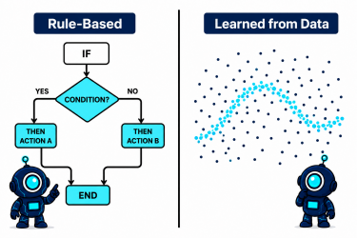Rule-based logic vs. patterns learned from data.
A rule-based AI system is predictable and explainable — you can point to the exact line of logic that produced a decision. But it's brittle: it only handles situations the programmer thought of in advance.
A machine learning system is more flexible and can handle situations no one explicitly anticipated — but it needs data to learn from, and its decisions are harder to fully explain, which matters a lot in engineering contexts where you need to trust a system's output.
A deep learning system is the most powerful and flexible of the three for complex, unstructured problems — images, language, sensor fusion — but it typically needs the most data, the most computing power, and is the hardest of the three to fully explain when it makes a decision.
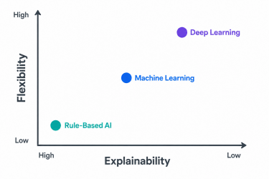Explainability vs. flexibility trade-off across the three categories.
A concrete example: how a system learns "cat"
A machine learning system shown thousands of cat photos doesn't get told what a cat is — it works out the shared pattern across the examples itself.
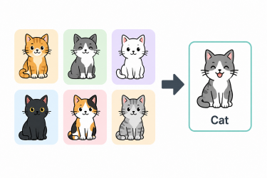Learning "cat" from many labeled examples, rather than a hand-written rule.
Where this shows up in engineering
A defect-detection camera on a production line is a practical example of this whole idea in action — it's a machine learning (often deep learning) system trained on examples of good and defective parts, flagging anomalies a rule-based system would likely miss.
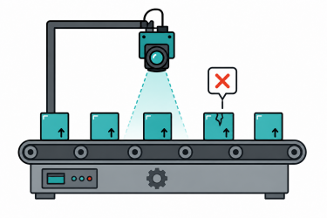A machine-learning-based defect detection system flagging a cracked part.
What AI, ML, and DL are not
None of these three things are "thinking" in the way a person thinks. A deep learning system finding a pattern in a million images of cats is doing sophisticated statistical pattern-matching — not developing an understanding of "cat-ness" the way a child does. This isn't a philosophical aside; it explains why these systems sometimes fail in strange, unhuman ways, a limitation you'll need to understand before you trust an AI system's output in any engineering application later in this course.
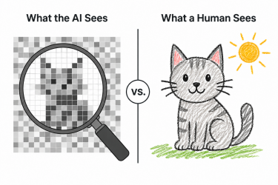What a deep learning system actually processes vs. how a human perceives the same image.
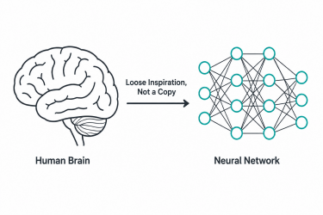Neural networks take loose inspiration from the brain — they are not a working replica of it.
Where this leaves you
By the end of this lesson, you should be able to look at any AI system — a chatbot, a defect-detection camera on a production line, a recommendation engine — and correctly place it in the nested boxes: rule-based AI, ML using structured data, or deep learning. That single skill is the foundation for every module that follows.
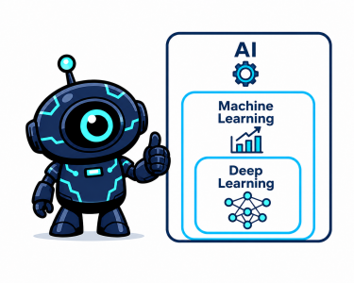Recap: AI, Machine Learning, and Deep Learning, nested.

